1. Add Visuals
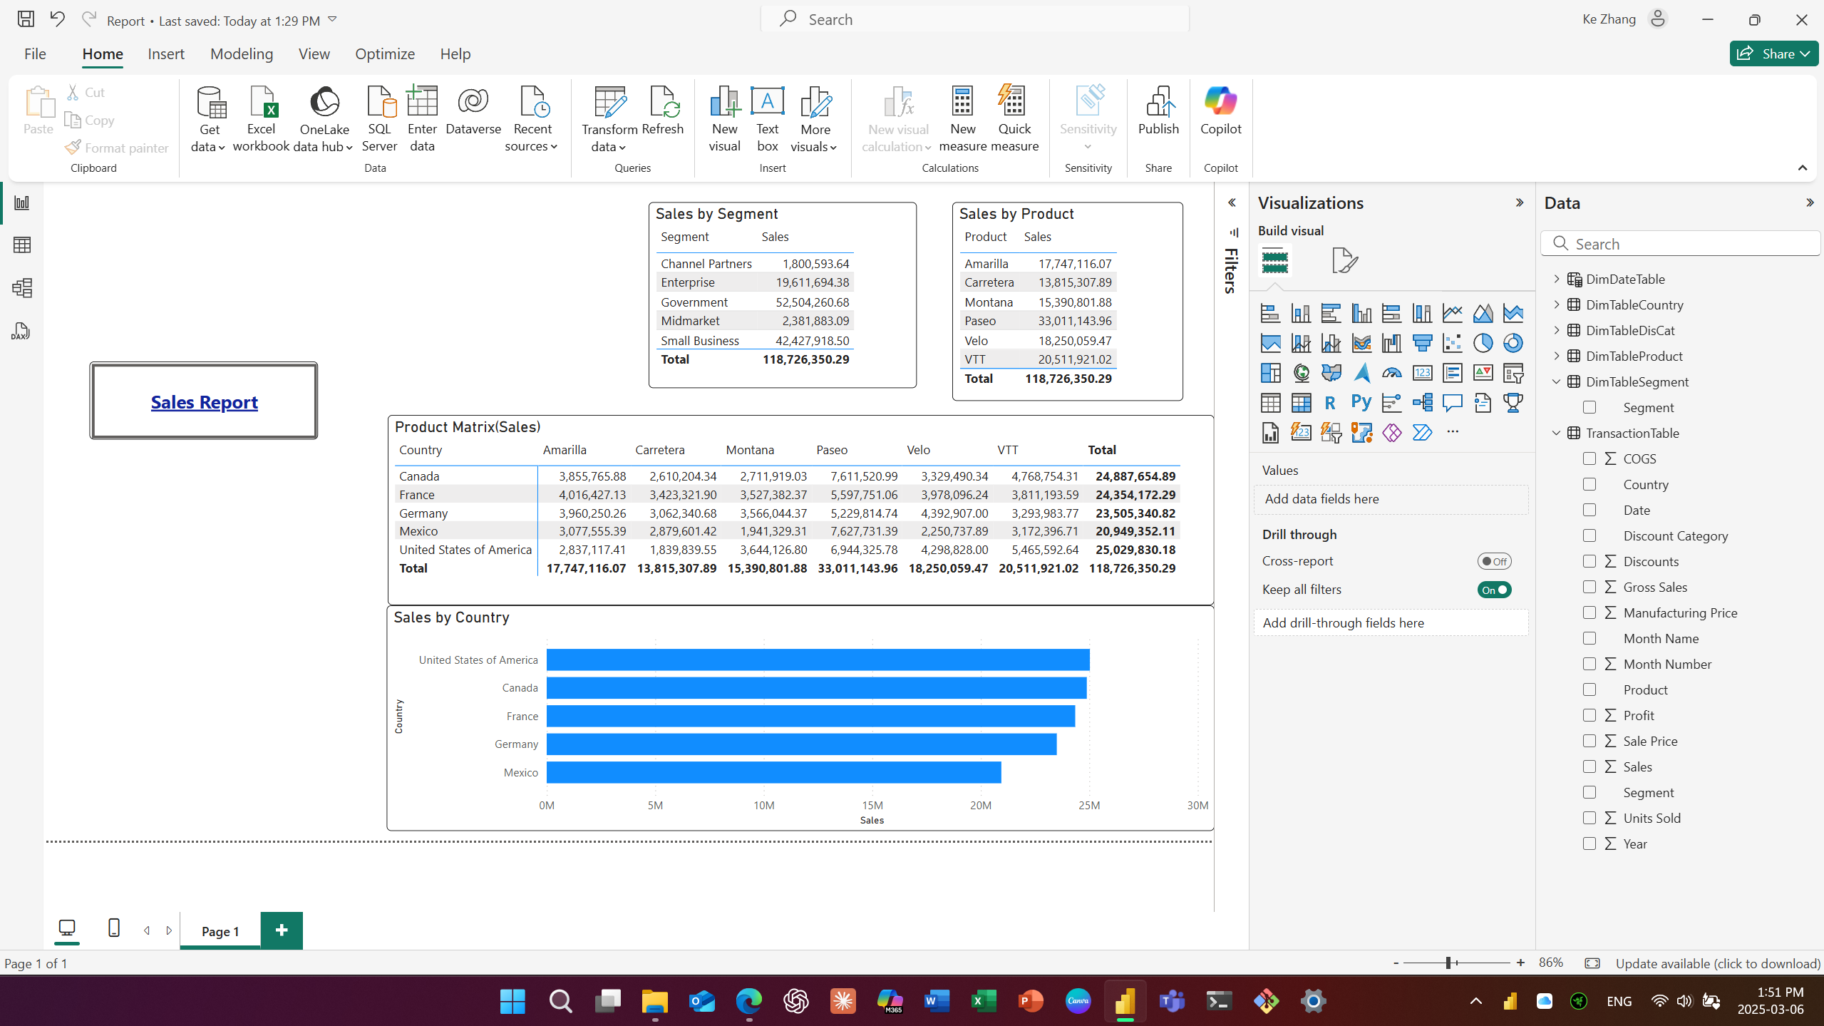
2.Add a Slicer to Report
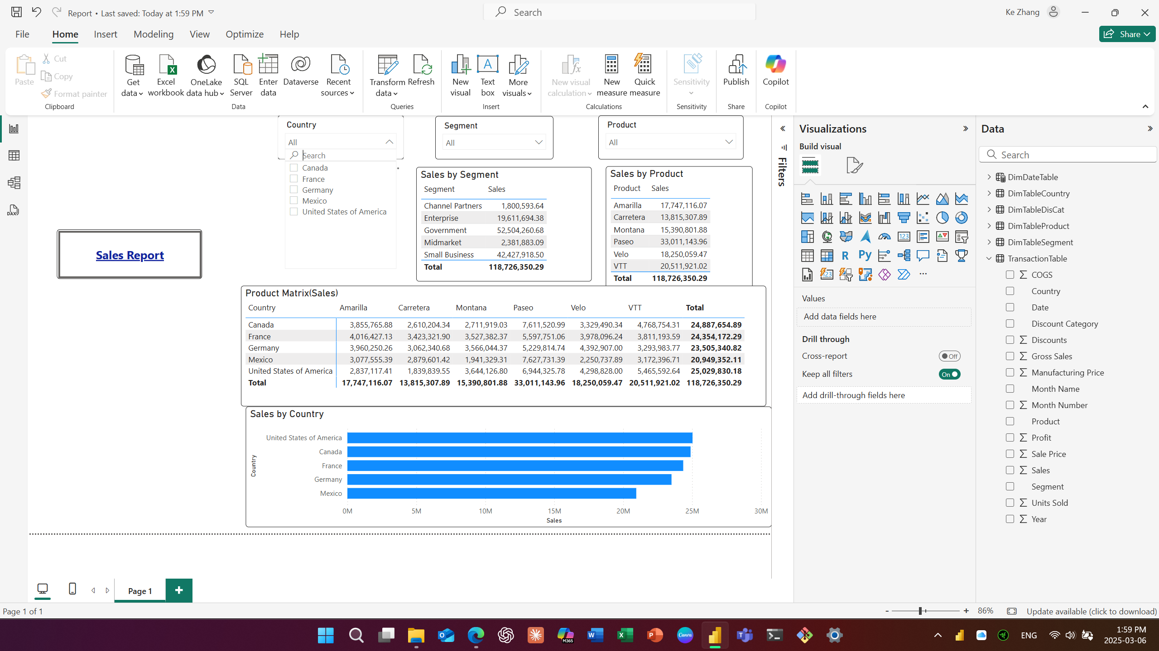
3. Control Which Visuals and Slicers Interact
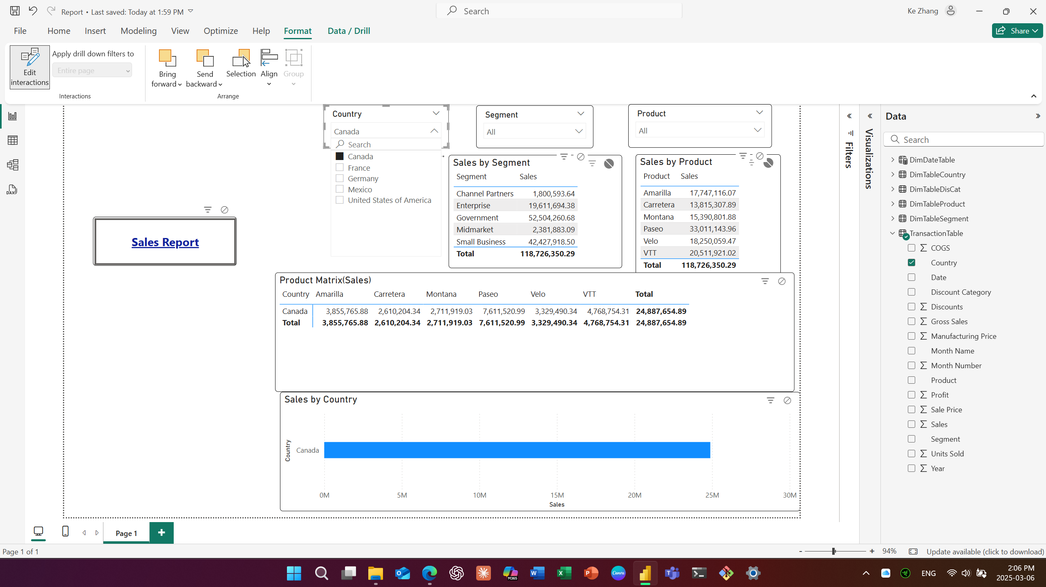
4. Enable and Control Drill Through Actions from Page1 to Page2
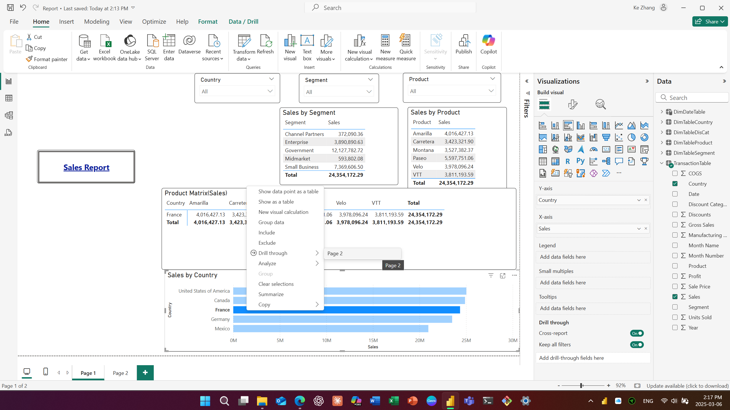
5.Split a Page into Sections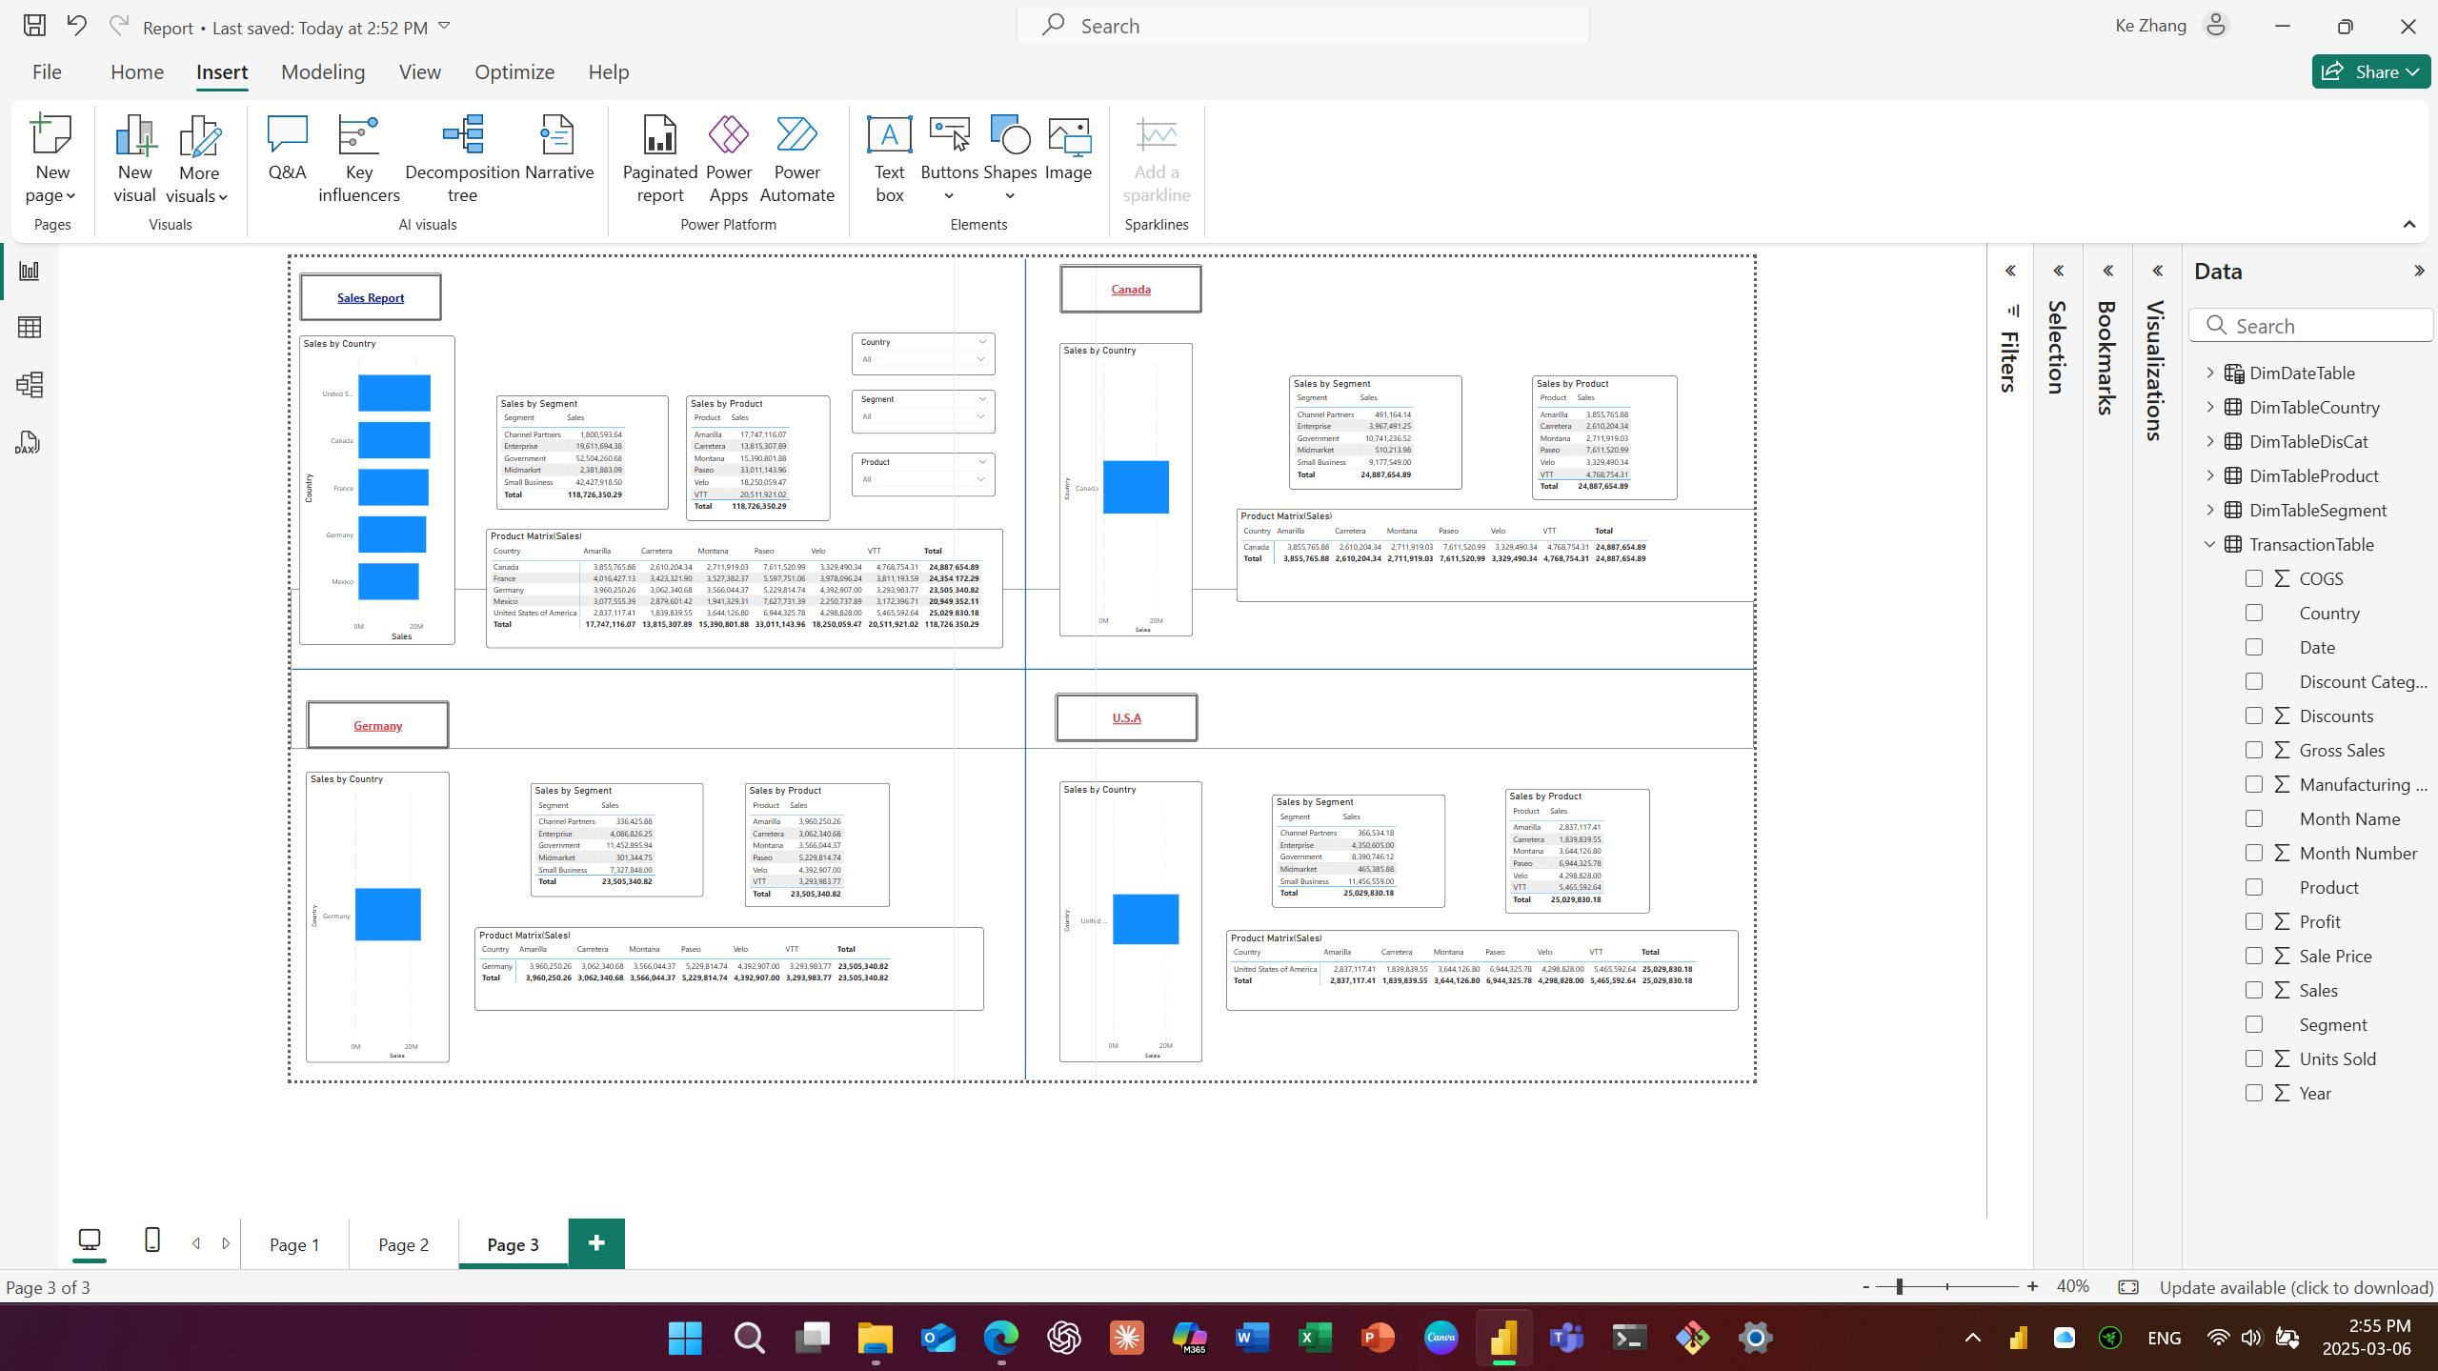

6.1 Add Bookmarks to a Report
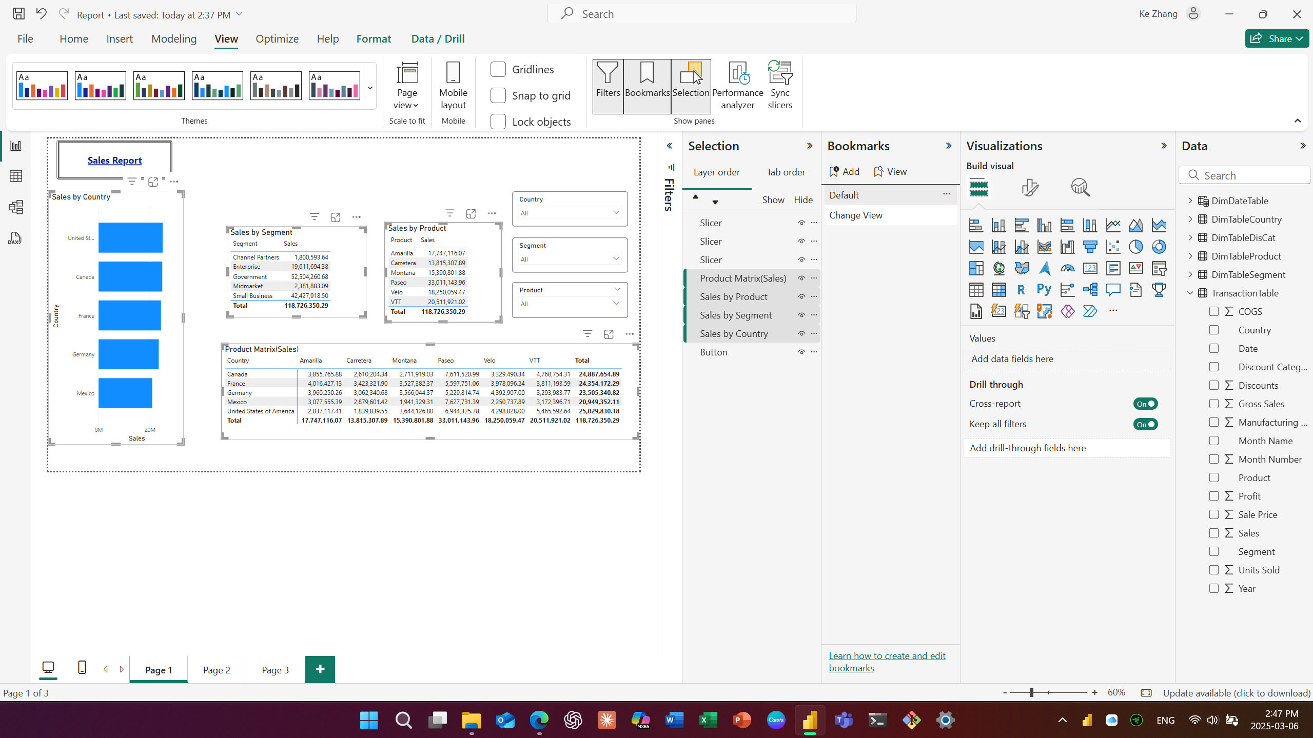
6.2 Add Bookmarks to a Report
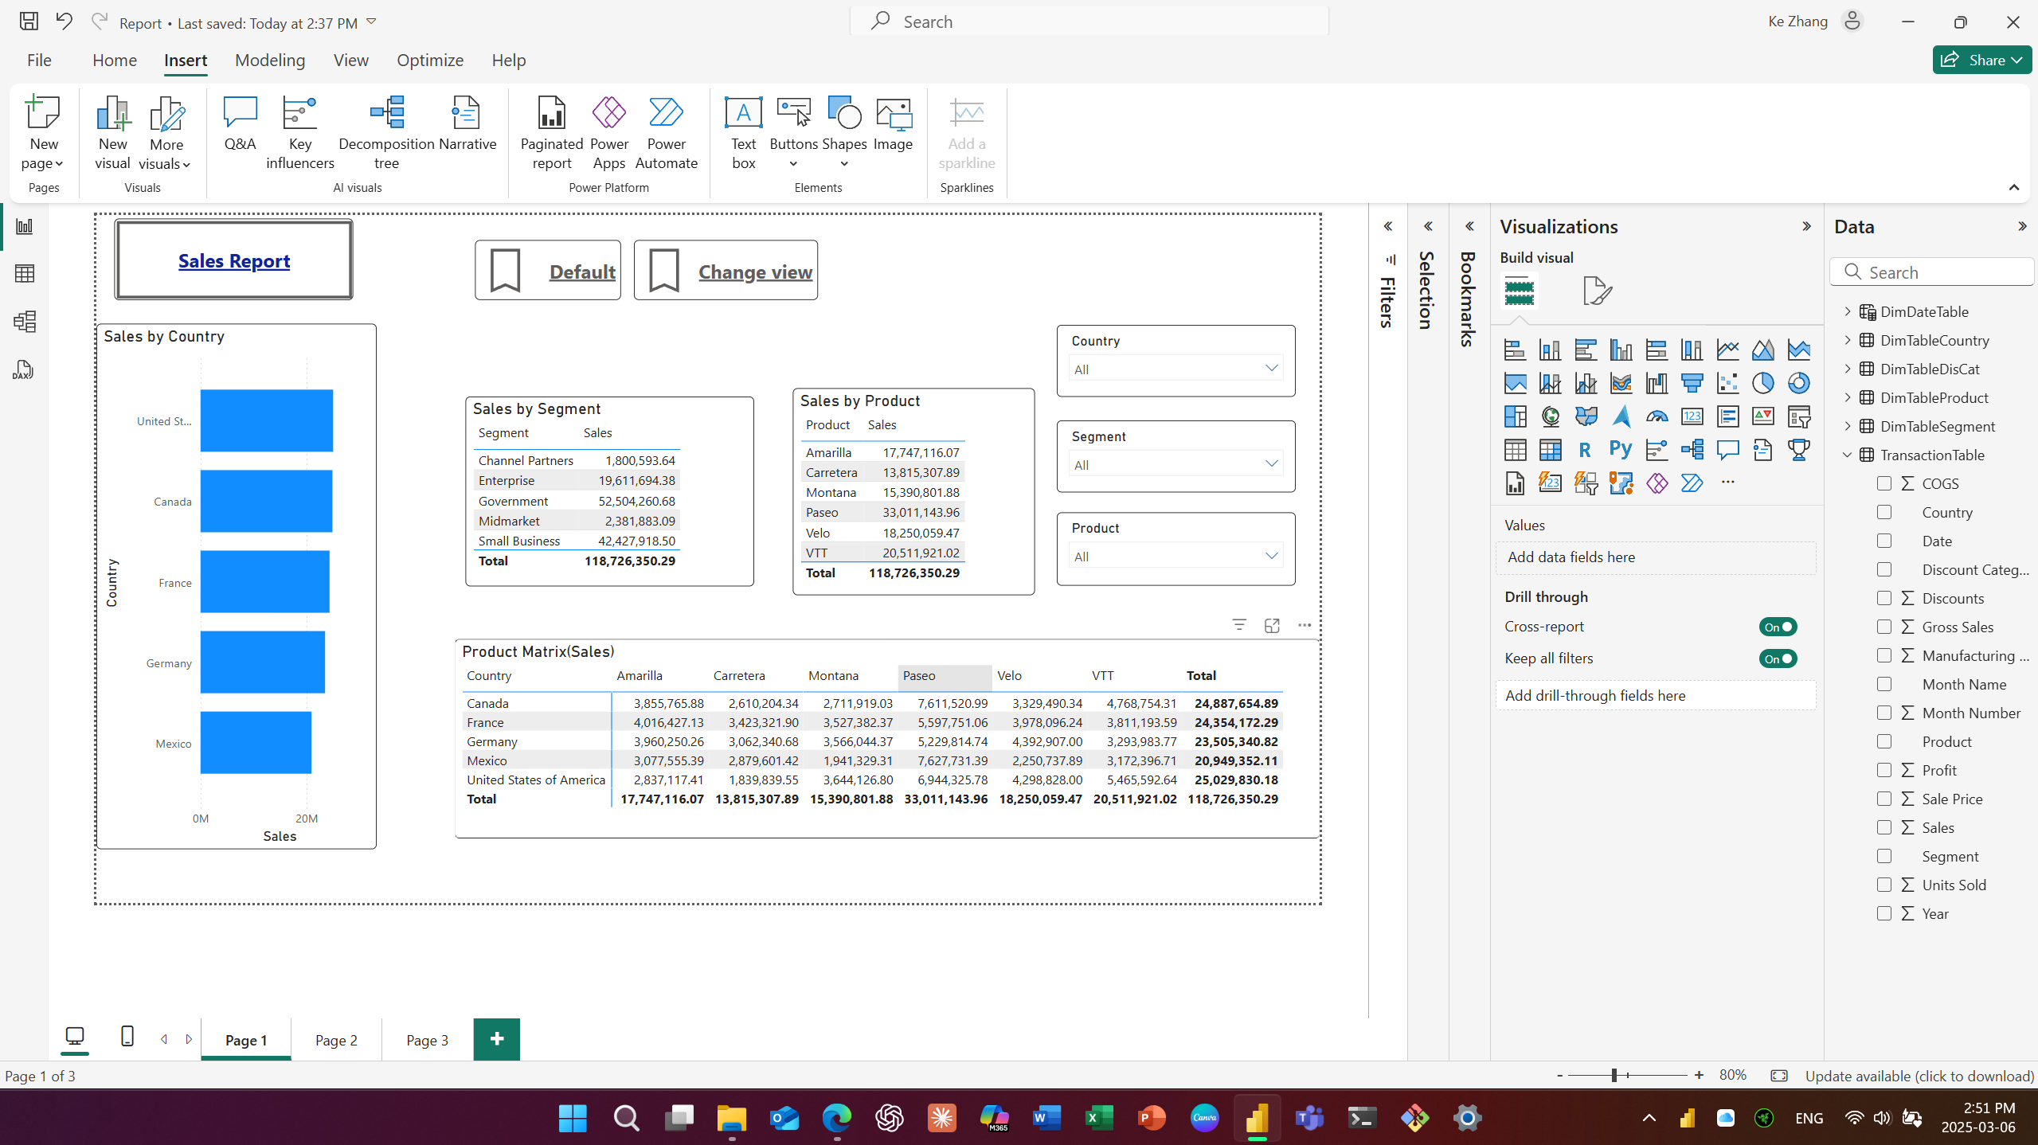
7. Add Page Navigation to a Report
